## Requesting a new WCS account

Before users are able to access the web ordering system, they must request a user account by completing the following steps.

1. Enter [www.webservices.averydennison.com](http://www.webservices.averydennison.com) into the web browser.

The below page will appear:

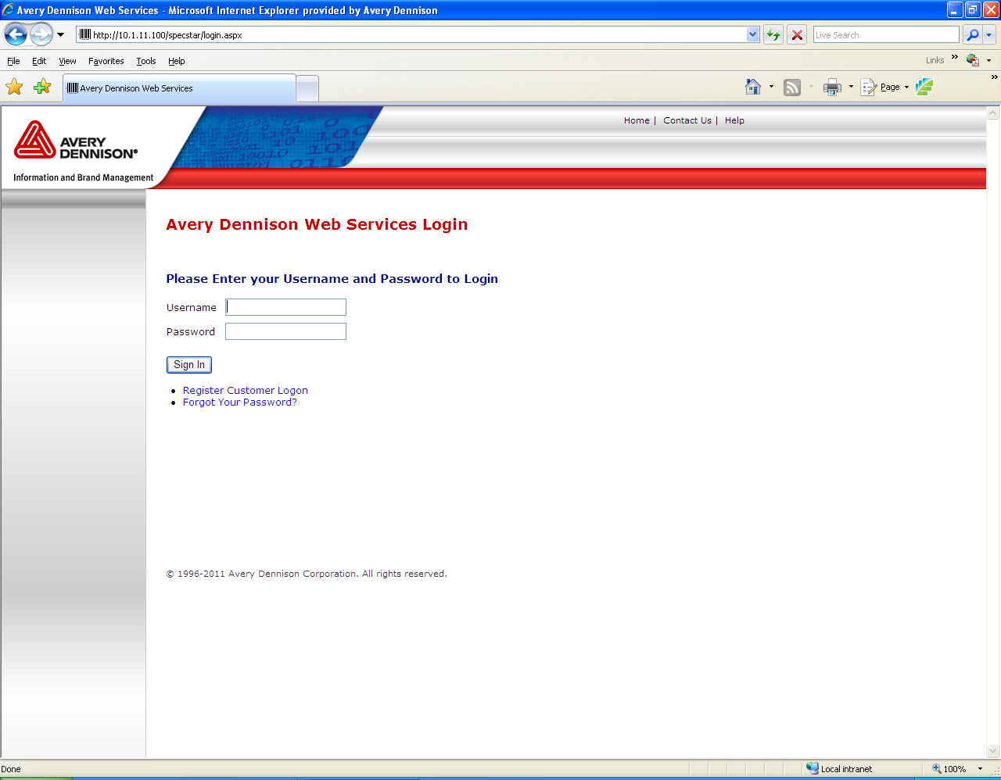

1. Select **Register Customer Logon**.

The below page will appear:

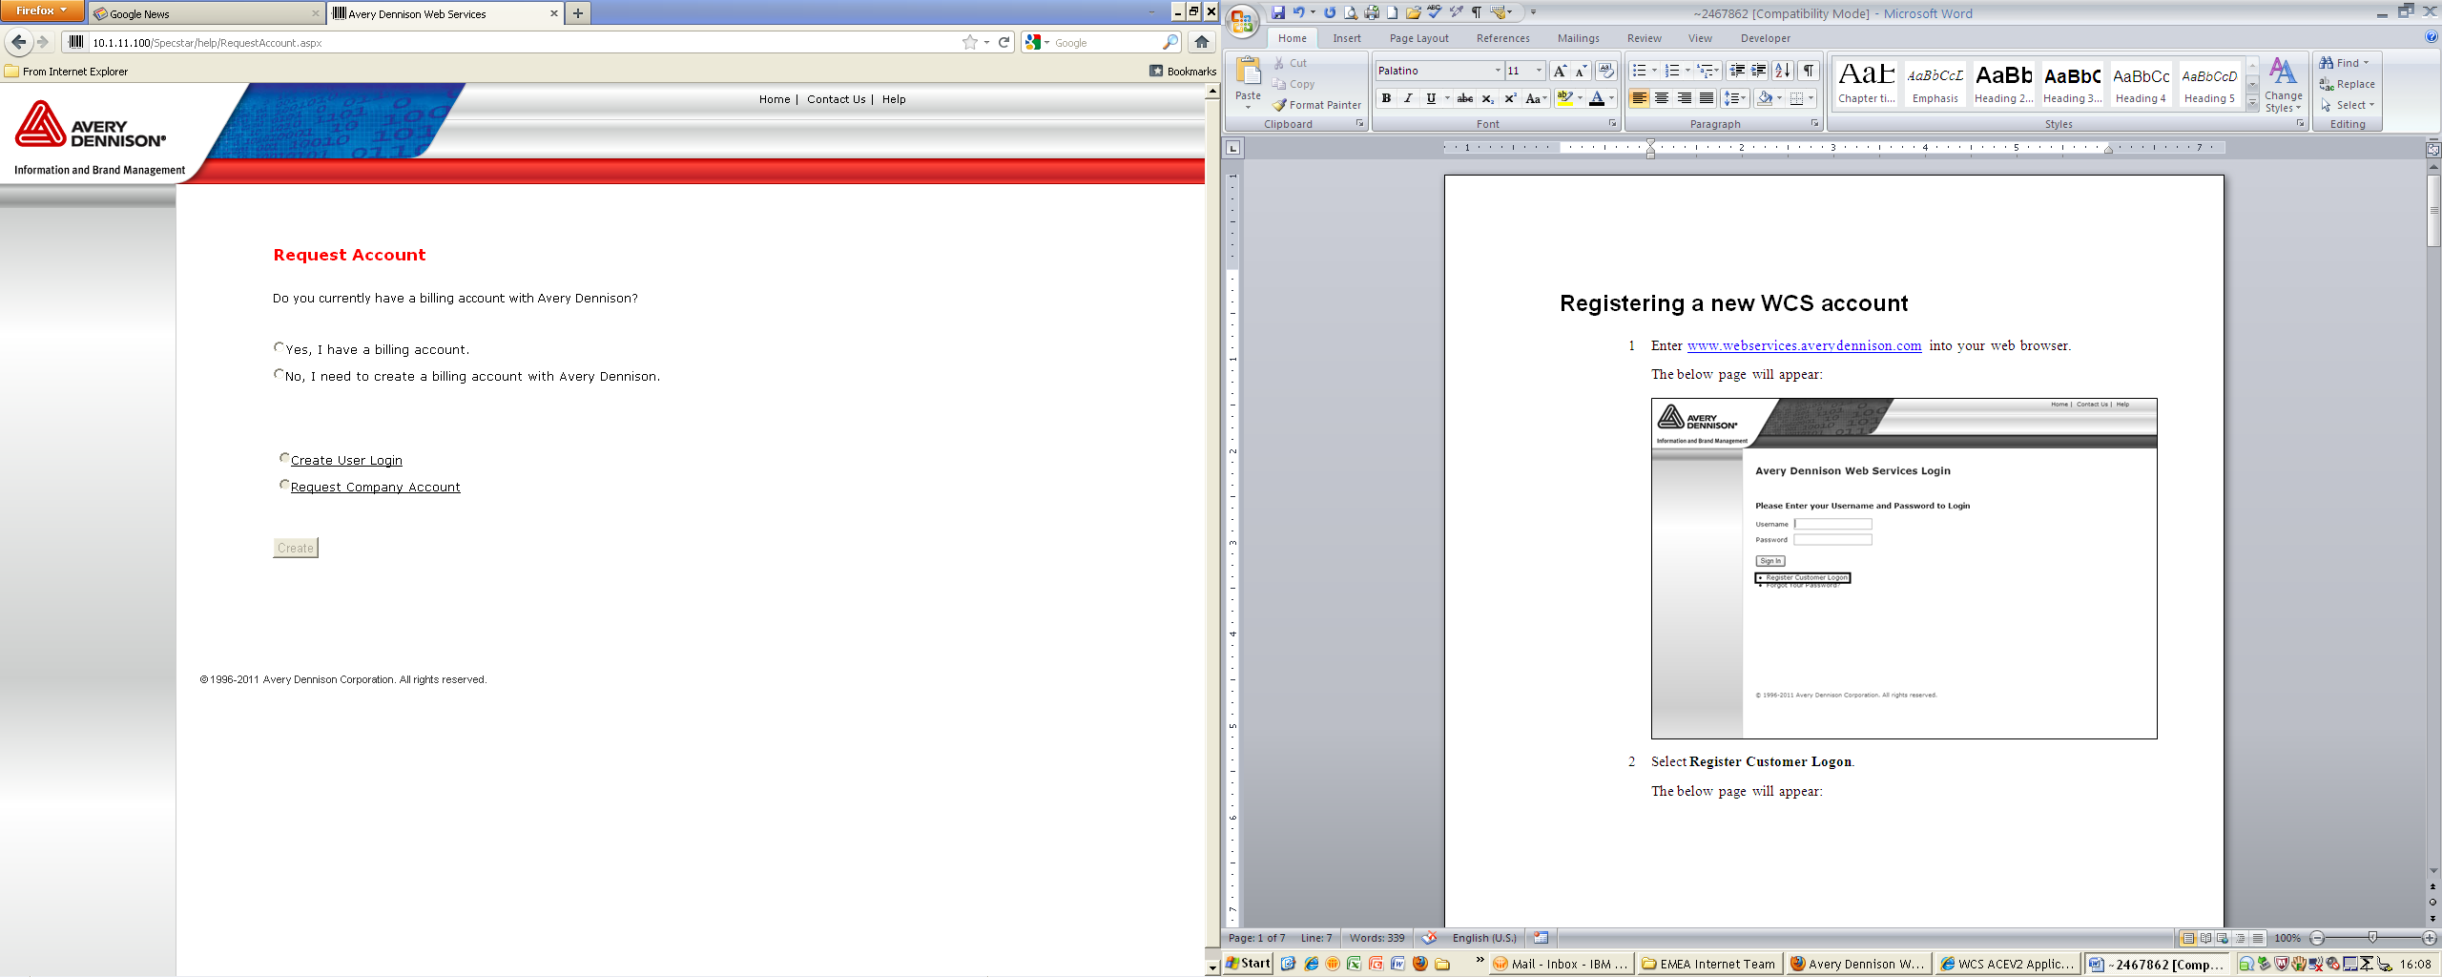

1. Please select “**Yes, I have a billing account.”**

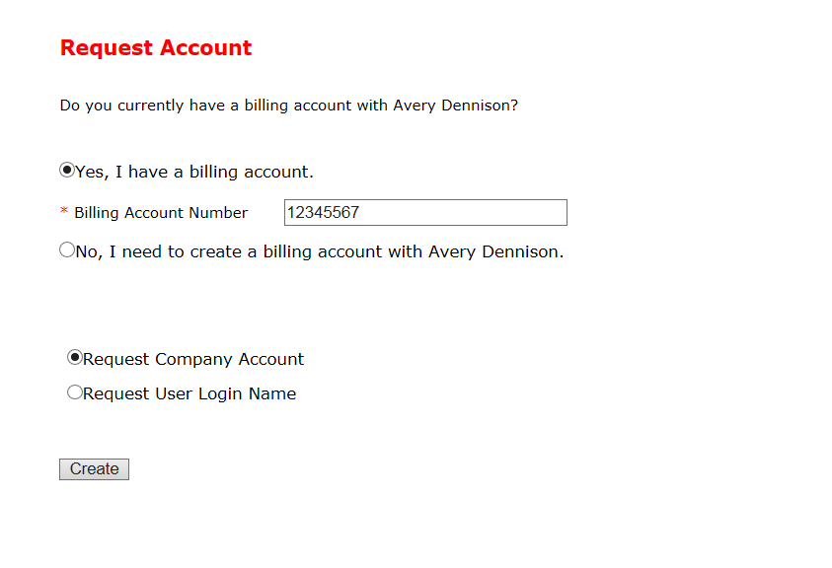

1. Select **Request Company Account.**
2. Click the **Create** button to proceed.

**NOTE: If you do not have a BILLING ACCOUNT :**

**please contact your dedicated customer service.**

## Company Registration

After selecting **Request Company Account**, you’ll be redirected to the below page.

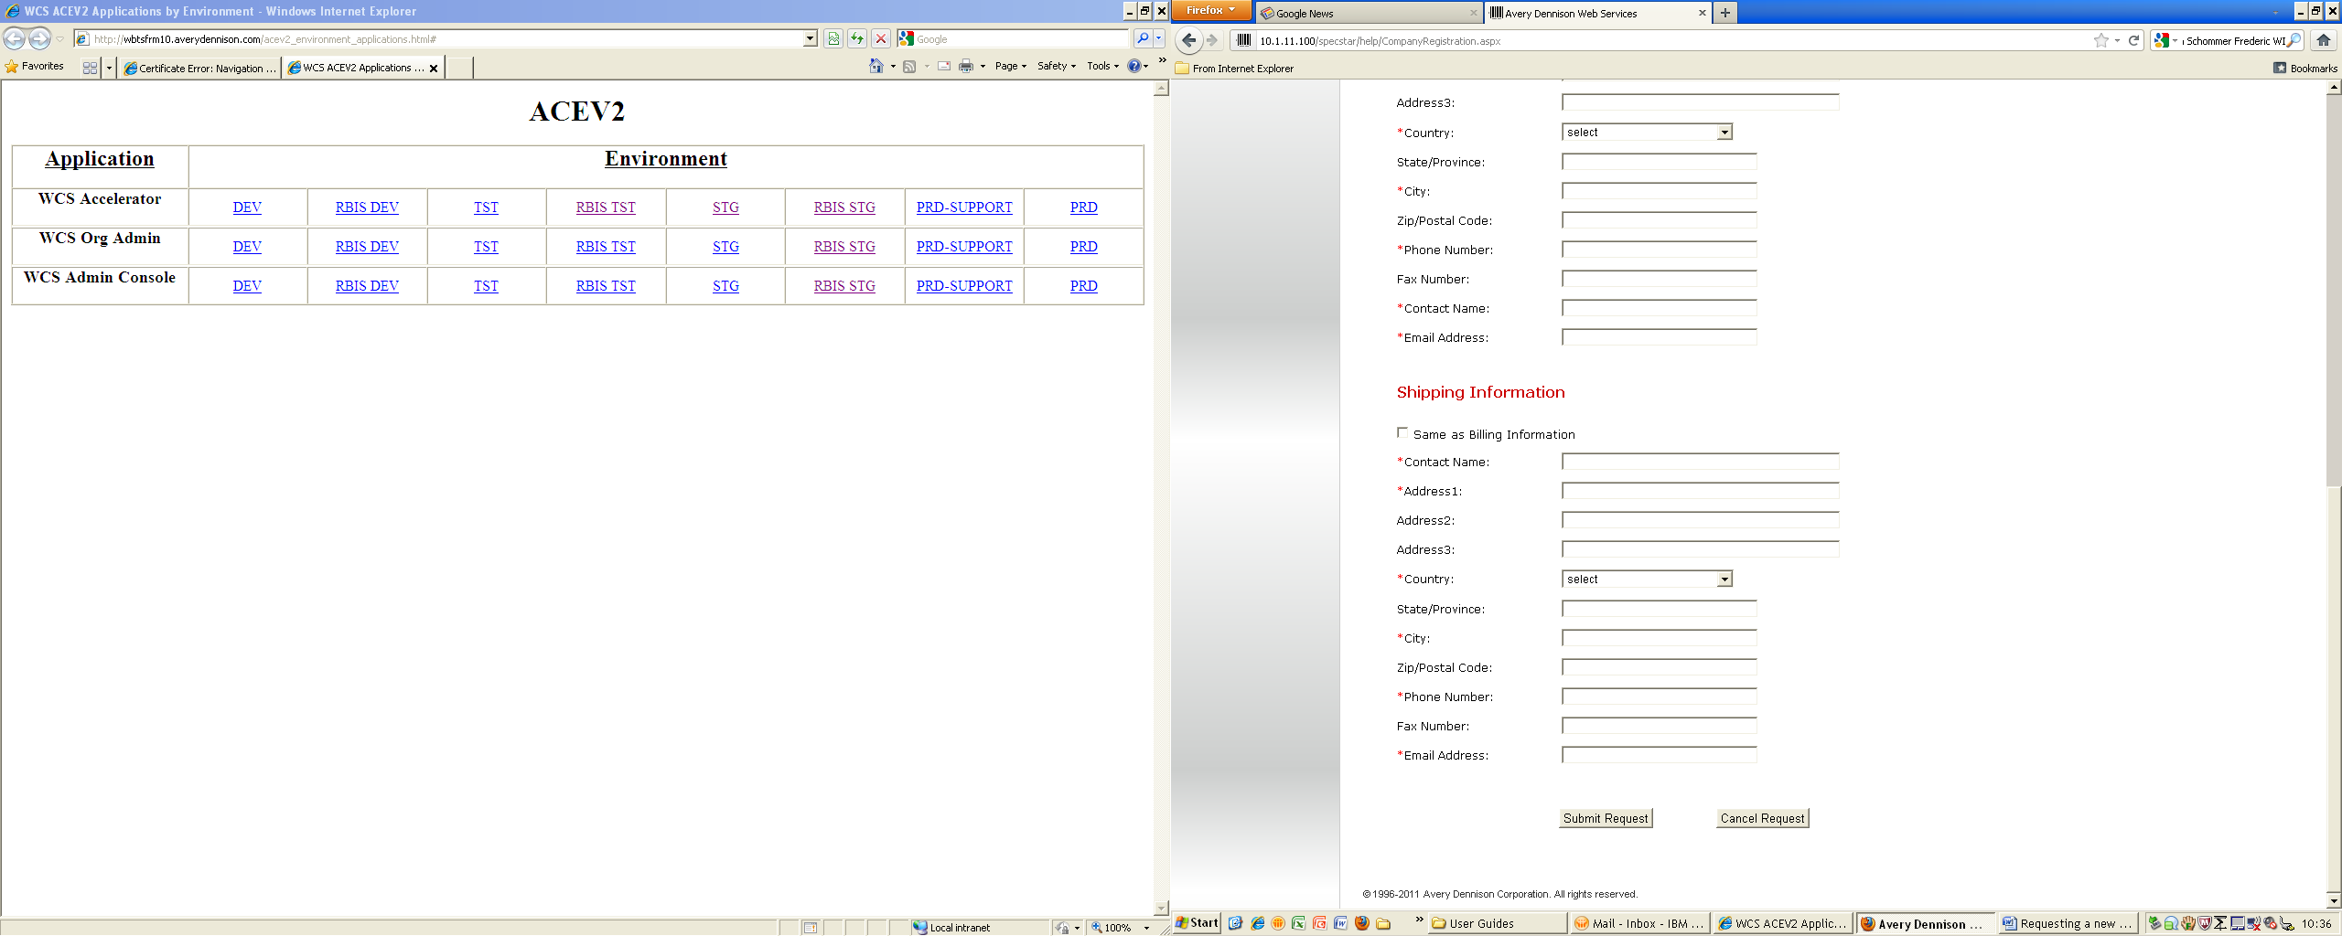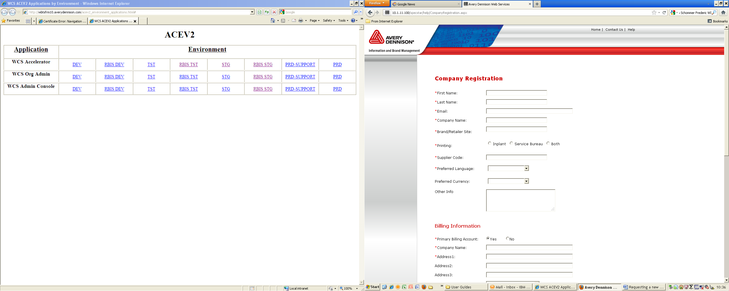

1. Fill in the form with the required information. All mandatory fields are marked with a red asterisk (**\***).
   1. Brand/Retailer Site is case sensitive. Please enter:

**WILLIAMS SONOMA**

* 1. Printing: Please select **Service Bureau**
  2. Supplier Code: Please enter your Williams Sonoma vendor ID Number.

1. After selecting a **Country**, the page will refresh. If a state or province must be selected, a drop down menu will appear in the **State/Province** field. Otherwise, a free text box will remain and the field will not be mandatory.
2. If the billing and shipping addresses are the same, check the **Same as Billing Information** selection box. This will cause the shipping information fields to populate automatically.
3. If the billing and shipping addresses are different, enter the shipping information into the relevant fields. You can only request one ship to address at this stage, if further addresses are required, these can be added through the Account section of the store front, which will be available when the user is logged into the web ordering system.
4. When all information has been entered, click **Submit Request**.
5. Once the user clicks the **Submit Request** button, an e-mail will automatically be sent to a Customer Service Representative to notify them that the request has been made.
6. To cancel the request, click **Cancel Request**. All information will be deleted, and the user will be redirected to the login page.

## Registration in Progress

Upon clicking the **Submit Request** you’ll receive the below confirmation message:

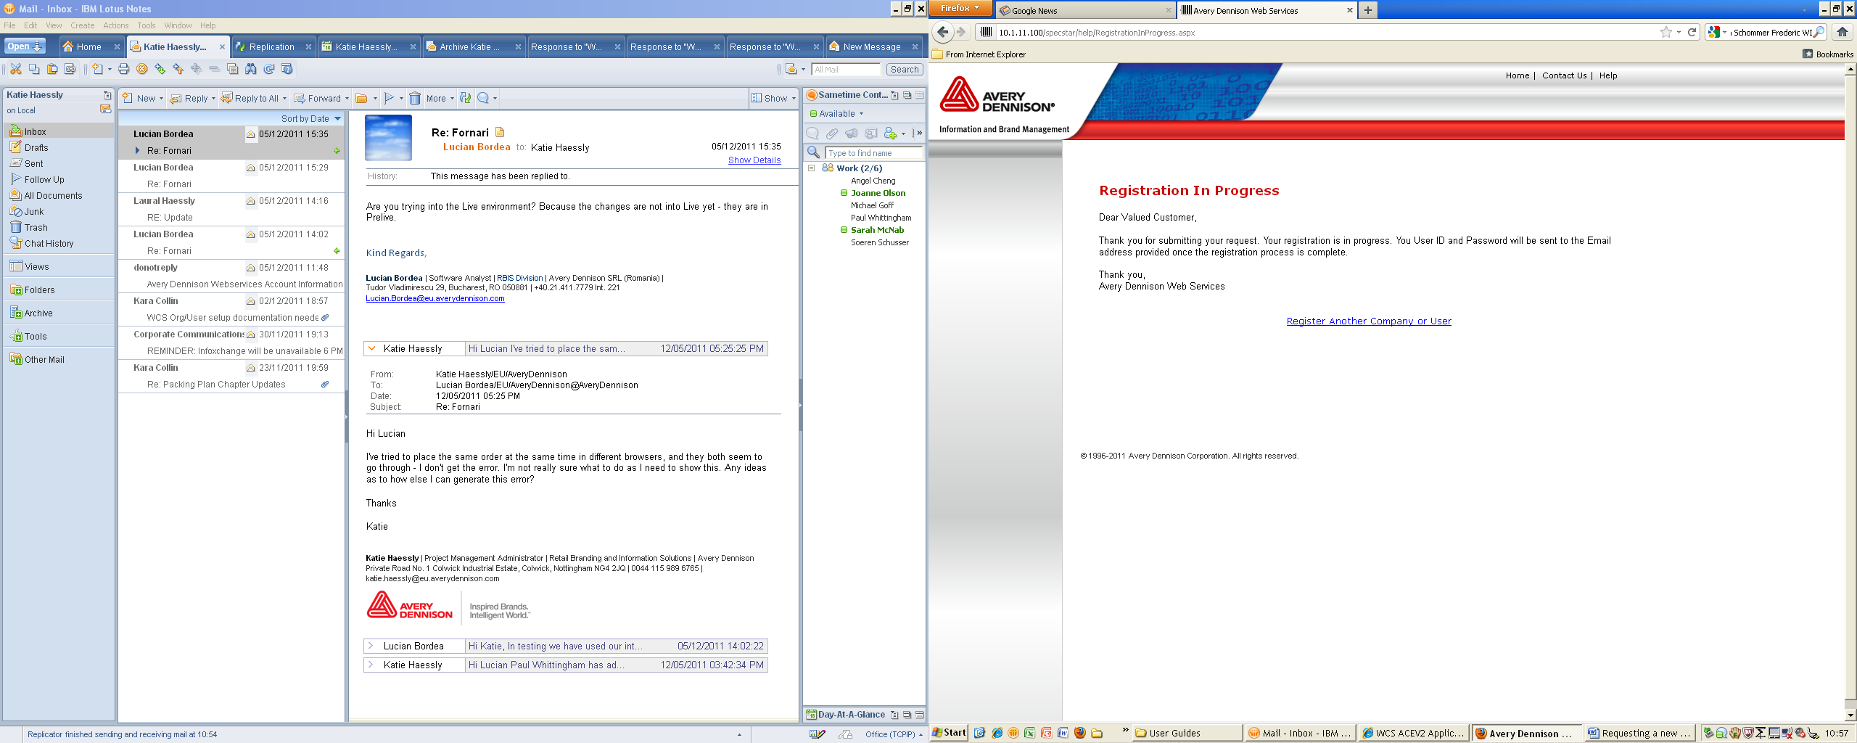

## User Logon Request

** Note: You may repeat this process to register multiple users for your account.

1. After you have completed your Company Registration, please return to the main page and follow steps 1-4 from page 1 of this guide.
2. Select **Request User Login Name**. You will be redirected to the below page.

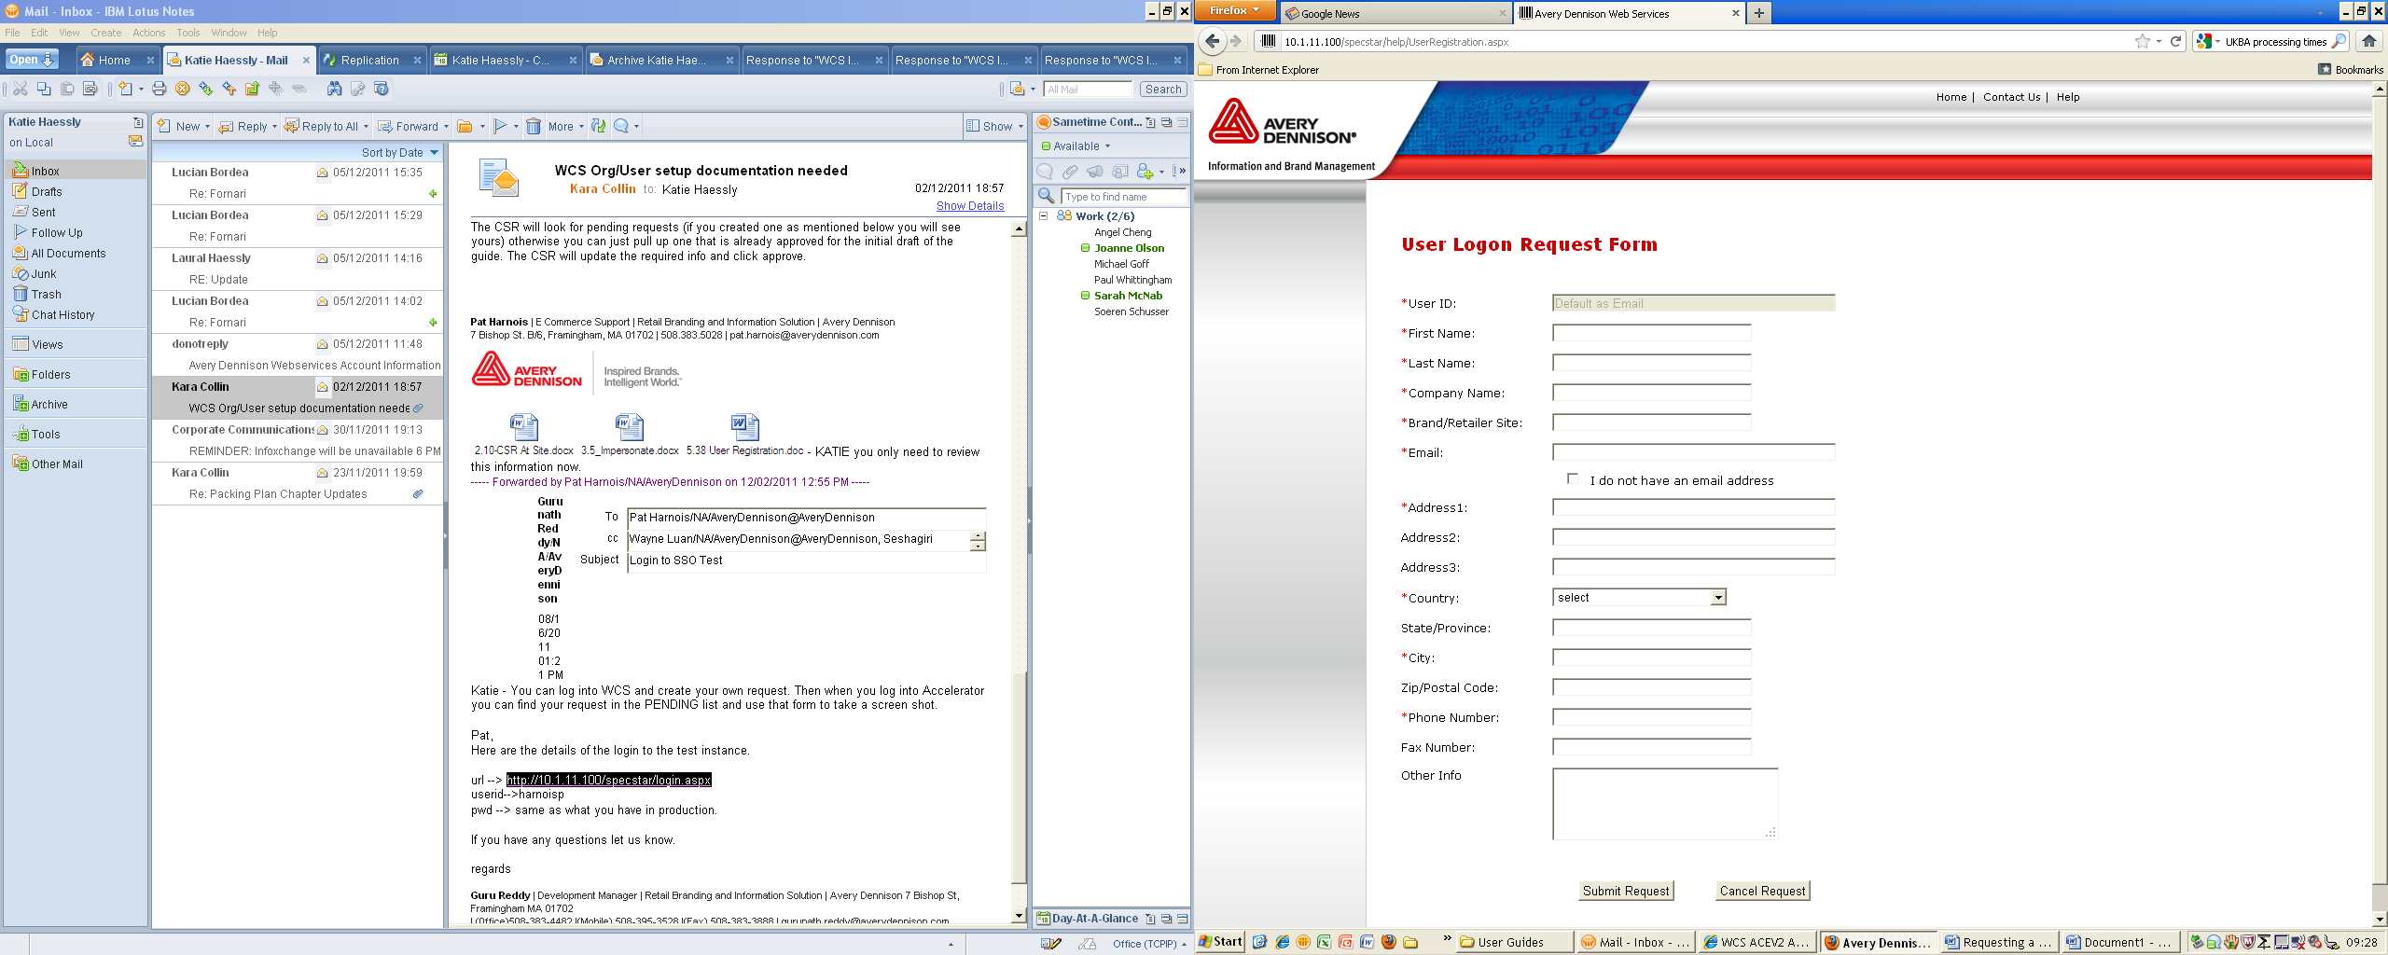

1. You will then need to fill in the form with the required information. All mandatory fields are marked with a red asterisk (**\***).
   1. Company Name: Please enter your company name exactly as typed on the Company Registration page
   2. Brand/Retailer Site is case sensitive. Please enter:

**WILLIAMS SONOMA**

1. After a **Country** is selected, the page will refresh. If a state or province must be selected, a drop down menu will appear in the **State/Province** field. Otherwise, a free text box will remain and can be left blank.
2. If you do not have an e-mail address, the **I do not have an email address** selection box should be chosen. This will cause the **User ID** field to become available and the **Email** field to become unavailable.
   1. **For users without e-mail addresses only** – users can select their own user IDs by filling in the **User ID** field. The username will be validated against all others in the system before registration is completed to ensure that it does not duplicate an already existing user ID.
3. When all information has been entered, click **Submit Request**.
4. To cancel the request, click **Cancel Request**. All information will be deleted, and you will be redirected to the login page.

## Registration in Progress

Upon clicking the **Submit Request** you’ll receive the below confirmation message:

